PIPETTE TIP BOX RECYCLING PROGRAM

- All brands of pipette tip boxes are accepted.

- Only recycle clean, empty and dry boxes. No pipette tips, pipettes or liquids.
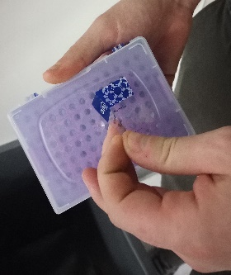

- Please remove all labels and stickers from pipette tip boxes before recycling.

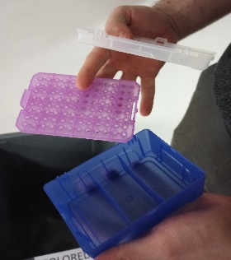

- Sort the box pieces into two different bins, one for colored plastic and one for clear. If the entire box and insert are the same color, there is no need to separate.

- Separate the lid from the base and remove the insert.

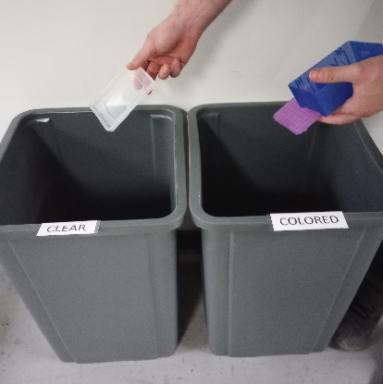
- Bins are located on each floor of buildings 2 and 4 in the wet lab hallway.

